Assignment 11 Austin Frownfelter

# Problem 1

## Part b

I used the logistic regression implementation from assignment 5. It uses an online gradient update with K steps, and uses a simple 0.5 value threshold for classifying 0/1.

## Part c

|  |  |  |  |  |  |  |
| --- | --- | --- | --- | --- | --- | --- |
|  | All |  |  | Wrapper |  |  |
|  | T | F | misclass | T | F | Misclass |
| T | 14 | 33 | 0.4253 | 6 | 10 | 0.2529 |
| F | 4 | 36 |  | 12 | 59 |  |
| Sens/spec | .7778 | .5217 |  | .3333 | .8551 |  |

The wrapper method decreased the misclassification rate significantly, but the sensitivity dropped with specificity increasing. This wrapper would typically give me only 1 or 2 features, with it sometimes giving me 3 or 4. This confusion matrix was for the set of {11, 30, 32, 8} features. I once got a set of features of size 5, but the confusion matrix was slightly worse than this one. Here, it is a choice of tradeoffs, having to choose between higher misclassification but fewer false negatives, or a lower misclassification but lower true positives.

# Problem 2

## Part a

|  |  |
| --- | --- |
| 7.55E+14 | 6.59E+10 |
| 1.14E+14 | 4.36E+10 |
| 2.69E+13 | 2.69E+10 |
| 1.07E+12 | 7.98E+09 |
| 7.89E+10 | 3.34E+09 |

## Part b

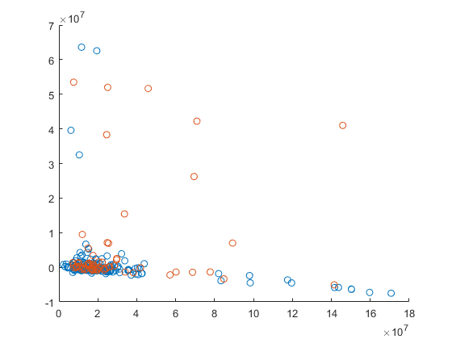

There is so much overlap between the two classes that it is hard to discriminate between them. In this case, 2 dimensions does not discriminate the classes well.

## Part c

|  |  |  |  |
| --- | --- | --- | --- |
|  | T | F | misclass |
| T | 1 | 4 | .2414 |
| F | 17 | 65 |  |
| Sens/spec | .0556 | .9420 |  |

This PCA with 5 components performed better than both previous methods in misclassification and specificity, but was abysmal in sensitivity. There was such a low true positive rate.

I decided to mess around with the number of principal components a little bit, and found 7 pc-s was quite better than 5, where you can trade a little bit of misclassification and specificity to gain a large amount of sensitivity.

|  |  |  |  |
| --- | --- | --- | --- |
|  | T | F | misclass |
| T | 11 | 24 | .2414 |
| F | 7 | 45 |  |
| Sens/spec | .0556 | .9420 |  |